**TRIBHUVAN UNIVERSITY**

**FACULTY OF COMPUTER SCIENCE**

**AND**

**INFORMATION TECHNOLOGY**



**A**

**Report On**

**NCCS Chatbot**

**Submitted to:**

**Computer Science and Information Technology**

**National College of Computer Science and Information Technology**

**Paknajol, Kathmandu**

**Submitted by:**

**Kriti Ghimire**

**College Reg: NCCS CSIT 461**

Table of Contents

Chapter 1: Introduction 1

Chapter 2: Problem Statement 2

Chapter 3: Objectives 3

Chapter 4: Methodology 4

**4.1 Requirement Identification** 4

4.1.1 Background Study 4

4.1.2 Literature Review 4

4.1.3 Requirement Analysis 6

**4.2 Feasibility Analysis** 7

4.2.1 Technical Feasibility 7

4.2.2 Operational Feasibility 7

4.2.3 Economic Feasibility: 7

4.2.4 Schedule Feasibility: 7

Chapter 5: System Flowchart 8

Chapter 6: Expected Outcome 9

Chapter 7: References 10

# Table of Figure

Figure 1: Use case diagram of NCCS Chat-bot 6

Figure 2: Gantt Chart 7

Figure 3: System Flowchart 8

# Chapter 1: Introduction

The NCCS-Chatbot represents a sophisticated virtual assistant tailored specifically for NCCS College, designed to streamline information retrieval processes for prospective and current students alike. It offers a comprehensive range of features, including detailed insights into the college's location, fee structures, course offerings, campus environment, and parking facilities. By leveraging advanced technologies such as Machine Learning (ML) and Natural Language Processing (NLP), the chatbot provides an intuitive and conversational interface where users can interact naturally and receive prompt responses akin to speaking with college authorities. This AI-driven approach ensures that queries are addressed swiftly and accurately, enhancing user satisfaction and facilitating informed decision-making. Implemented using Python for backend development and incorporating HTML, CSS and JavaScript for frontend. The chatbot is robust and scalable. Future enhancements may include multilingual support, voice interaction capabilities, and further personalization to cater to the diverse needs of its users, solidifying its role as a pivotal tool in the NCCS College community.

# Chapter 2: Problem Statement

The problem statement for NCCS Chatbot is that the current methods of accessing college information, such as phone calls or emails, often prove inefficient and time-consuming for users. This limitation results in extended waiting periods, sometimes spanning hours or days, which can frustrate applicants and delay the enrollment process. Moreover, traditional communication channels like email and phone calls can feel impersonal and may not fully address users' specific needs, leading to repetitive queries and navigation through cumbersome phone menus. Particularly with complex academic inquiries concerning admission procedures, fee structures, scholarship opportunities, and document requirements, the process becomes further convoluted. Addressing these queries through conventional means requires substantial resources and can result in delays in providing accurate and comprehensive information to prospective students and their families.

# Chapter 3: Objectives

* To provide 24/7 access to college information like admissions, fees, courses and so on.
* To minimize the need for in-person visits or calls.

# Chapter 4: Methodology

## Requirement Identification

### 4.1.1 Background Study

A Chatbot is a software application that uses artificial intelligence (AI) and natural language processing (NLP) to simulate human conversation with users. Chabot can be designed to interact with users through a messaging interface, voice-enabled devices, or chat windows on websites and mobile apps.

The first Chatbot, ELIZA [1], was created in the 1960s by Joseph Weizenbaum at MIT. ELIZA was designed to simulate a therapist and could engage in simple conversational exchanges with users. It uses pattern matching and substitution methodology to simulate conversation. Designed to convincingly simulate the way a human would behave as a conversational partner. However, it was limited in its ability to understand the context of a conversation and provide meaningful responses.

A Chatbot is often described as one of the most advanced and promising expressions of interaction between humans and machines. However, from a technological point of view, a Chatbot only represents the natural evolution of a Question Answering system leveraging Natural Language Processing (NLP). Formulating responses to questions in natural language is one of the most typical Examples of Natural Language Processing applied in various enterprises’ end-use applications.

With the advancements in AI and NLP technologies, Chatbot have become more sophisticated and can now handle complex conversations, make recommendations, answer queries, and even perform tasks for users. Today, chatbots are used in various industries, such as customer service, healthcare, finance, education, and entertainment, to enhance user experience, streamline processes, and reduce costs.

### Literature Review

A literature review for a college chatbot project would typically explore existing research, studies, and implementations related to chatbots in educational settings.

WorldLink's chatbot is a virtual assistant driven by artificial intelligence that can assist consumers with a variety of chores and inquiries. It can help you handle internet or NETTV issues, recover forgotten passwords, manage accounts, and more. The chatbot is available 24/7 via the WorldLink website and WhatsApp, allowing clients to obtain assistance at any time. It gives prompt and individualized responses while also providing efficient and consistent service. The chatbot's straightforward and user-friendly design ensures that clients can quickly and easily solve their concerns [2].

A Literature Survey of Recent Advances on Chatbots provides an in-depth examination of the development and present condition of chatbot technologies, highlighting the incorporation of Artificial Intelligence (AI) and Natural Language Processing (NLP). It outlines essential developmental stages in chatbot systems, from initial rule-based designs to sophisticated deep learning techniques that have greatly enhanced response creation and context management.   
  
A key emphasis of the paper is on advancements in algorithms, especially the implementation of models such as Sequence-to-Sequence (Seq2Seq) and Transformer architectures (for instance, BERT, GPT). These models have allowed chatbots to produce more coherent, contextually appropriate, and human-like replies, surpassing the constraints of conventional pattern-matching methods. [3]

The "Role of AI Chatbots in Education: Systematic Literature Review" offers a thorough examination of 67 papers to evaluate the use of AI chatbots in classrooms. It emphasizes the advantages for students, including skill improvement, instant support, and individualized learning experiences. Teachers gain from improved instructional techniques and time-saving features. On the other hand, the study also discusses issues with fair assessment procedures, data protection and responsible AI use, and the accuracy and dependability of chatbot responses. To optimize the use of AI chatbots in education, the authors stress the necessity of cautious deployment and continual assessment.

While acknowledging the role of advanced AI technologies, like natural language processing (NLP) and machine learning (ML), in enabling chatbots to simulate human-like interactions and provide contextually appropriate responses, the paper does not go into great detail about specific algorithms or technical methodologies used in chatbot development, despite its primary focus on the applications and implications of AI chatbots in education. This suggests that future research should investigate the technical aspects of chatbot design and implementation to further enhance their effectiveness in educational contexts. [4]

### Requirement Analysis

The NCCS Chatbot requirement analysis entails identifying and defining the features, functionalities, and requirements necessary for the website to run effectively and efficiently.

**Functional Requirement**

* The user shall ask the queries.
* The user shall be able to view the responses.
* The user shall be able to listen the response.

**Non-functional Requirement**

* The system must have simple and user-friendly UI.
* The system is available 24/7.
* The system must have a good response.
* The system must be maintainable.

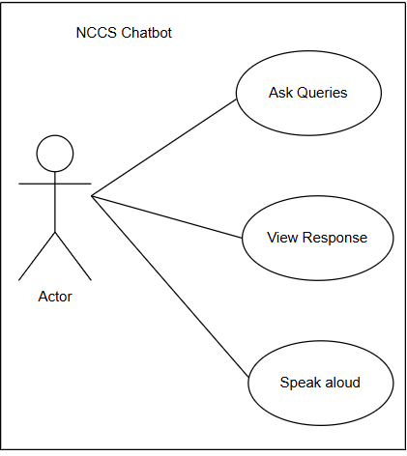

Figure 1: Use case diagram of NCCS Chat-bot

## **4.2 Feasibility Analysis**

A feasibility study for the NCCS College chat-bot involves evaluating whether developing and deploying the chatbot is practical and beneficial.

### 4.2.1 Technical Feasibility

Our project was developed within Intel Core i5 2.4 GHz, 4GB RAM and windows 11 OS. So that it can support every user’s device.

### 4.2.2 Operational Feasibility

The chatbot should be easy for students, staff, and stakeholders to use. It must provide clear, accurate answers to common questions, such as admissions processes, fees, course details, and more. The system must be scalable, capable of handling a large number of simultaneous users, especially during peak times like enrollment periods.

### 4.2.3 Economic Feasibility:

The project can be developed in a very cost-effective way because the project would be using open-source software like python which is available free online. Also, the benefits of the project outweigh the cost. Hence the project can be deemed economically feasible.

### 4.2.4 Schedule Feasibility:

The Gantt chart of the project is as follow:

|  |  |  |  |  |  |  |  |  |  |  |
| --- | --- | --- | --- | --- | --- | --- | --- | --- | --- | --- |
| Activities/Duration | Week 1 | Week 2 | Week 3 | Week 4 | Week 5 | Week 6 | Week 7 | Week 8 | Week 9 | Week 10 |
| Planning |  |  |  |  |  |  |  |  |  |  |
| Research |  |  |  |  |  |  |  |  |  |  |
| Data Gathering |  |  |  |  |  |  |  |  |  |  |
| Requirement  Analysis |  |  |  |  |  |  |  |  |  |  |
| Coding |  |  |  |  |  |  |  |  |  |  |
| Testing |  |  |  |  |  |  |  |  |  |  |
| Validation |  |  |  |  |  |  |  |  |  |  |
| Documentation |  |  |  |  |  |  |  |  |  |  |

Figure 2: Gantt Chart

# Chapter 5 : Implementation

# Chapter 5: System Flowchart

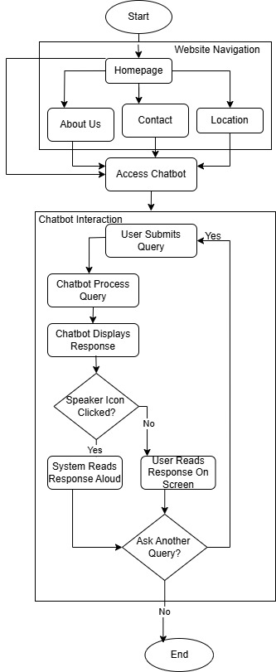

Figure 3: System Flowchart

# Chapter 6: Expected Outcome

The implementation of the NCCS Chatbot is expected to significantly enhance the communication and information retrieval process for students, staff, and prospective enrollees at NCCS College. By providing instant, 24/7 responses to inquiries regarding admissions, fees, courses, campus facilities, and more, the chatbot will reduce the dependency on traditional communication methods such as in-person visits or phone calls, which are often time-consuming and inefficient. This automation will improve user satisfaction, increase institutional responsiveness, and help students make informed decisions more quickly and effectively.

Technically, the chatbot is designed with advanced Natural Language Processing (NLP) and Long Short-Term Memory (LSTM) neural networks to ensure accurate understanding and response to user queries. The system will be integrated with a simple web-based interface and backend logic built in Python, offering both text and speech responses for greater accessibility. In the long term, this project lays a foundation for more intelligent virtual assistants in educational institutions, with room for future enhancements such as multilingual support, mobile app integration, and voice command functionality to create a more dynamic and inclusive user experience.

# Chapter 7: References

|  |  |
| --- | --- |
| [1] | "ELIZA," 13 september 2024. [Online]. Available: https://en.wikipedia.org/wiki/ELIZA. |
| [2] | "WorldLink ChatBot: Transforming the best service with AI," Wordlink, 4 october 2023. [Online]. Available: https://worldlink.com.np/worldlink-chatbot/. |
| [3] | S. J. ,. M. Guendalina Caldarini, "A Literature Survey of Recent Advances in Chatbots," 15 January 2022. [Online]. Available: https://www.mdpi.com/2078-2489/13/1/41. [Accessed 20 May 2025]. |
| [4] | M. G. M. Lasha Labadze, "Role of AI chatbots in education: systematic literature review," 23 October 2023. [Online] Available: https://educationaltechnologyjournal.springeropen.com/articles/10.1186/s41239-023-00426-1. [Accessed 20 May 2025]. |